**What is use of functions > REUSABILITY**

**Notes > REUSABILITY functions > Reusablity**

**Share ur notes with ur friends class library >**

**Publish them on internet only in India Web service (serice aval on web)**

**Publish them on internet globally web api (service aval on web)**

**REUSABLITY**

Notes : We don’t have to start reading frm beginning again : functions

Share notes with ur friends : DLL

Publish them on web :web service

Console Application : exe

Windows : exe

Class Library : dll

We want to make a project which will only contains methods which can be used across

Different projects

For that we select which template **“CLASS LIBRARY”**

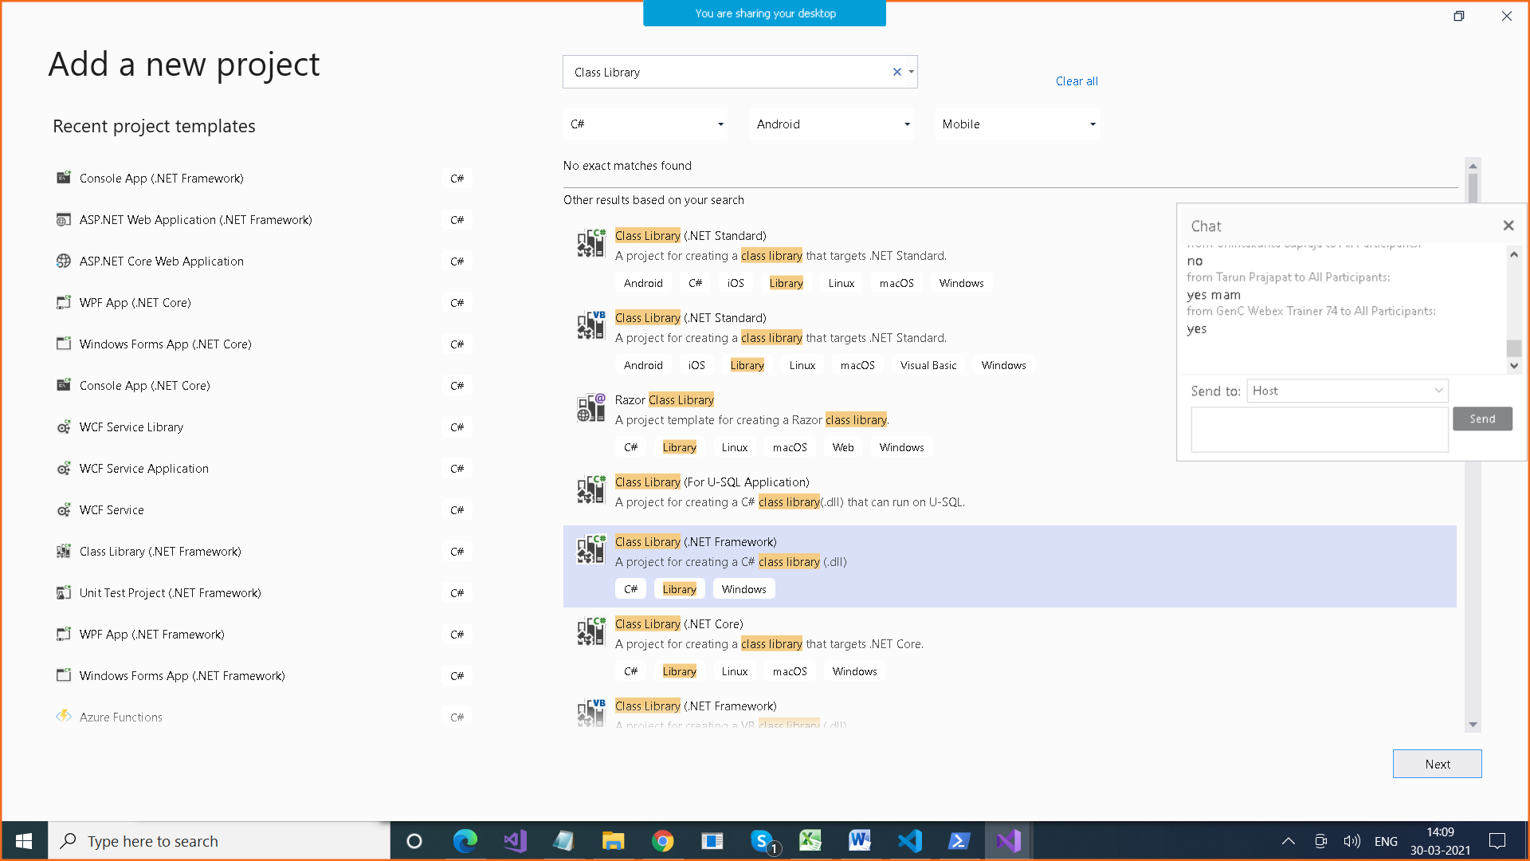

When you build it, we get dll (dynamic link library)

Functions : Reusablity

DLL (Dynamic Link Library) : A project which contains functions

Web Service : Service available on Web (XML)

WCF : Windows Common Foundation

Web services can be consumed from browser

Web API : These contains methods , can be accessed from all devices

RESTFUL SERVICES They are HTTP Services , they use HTTP protocol

Alongwith some verbs

GET , POST , PUT , DELETE

How to consume dll

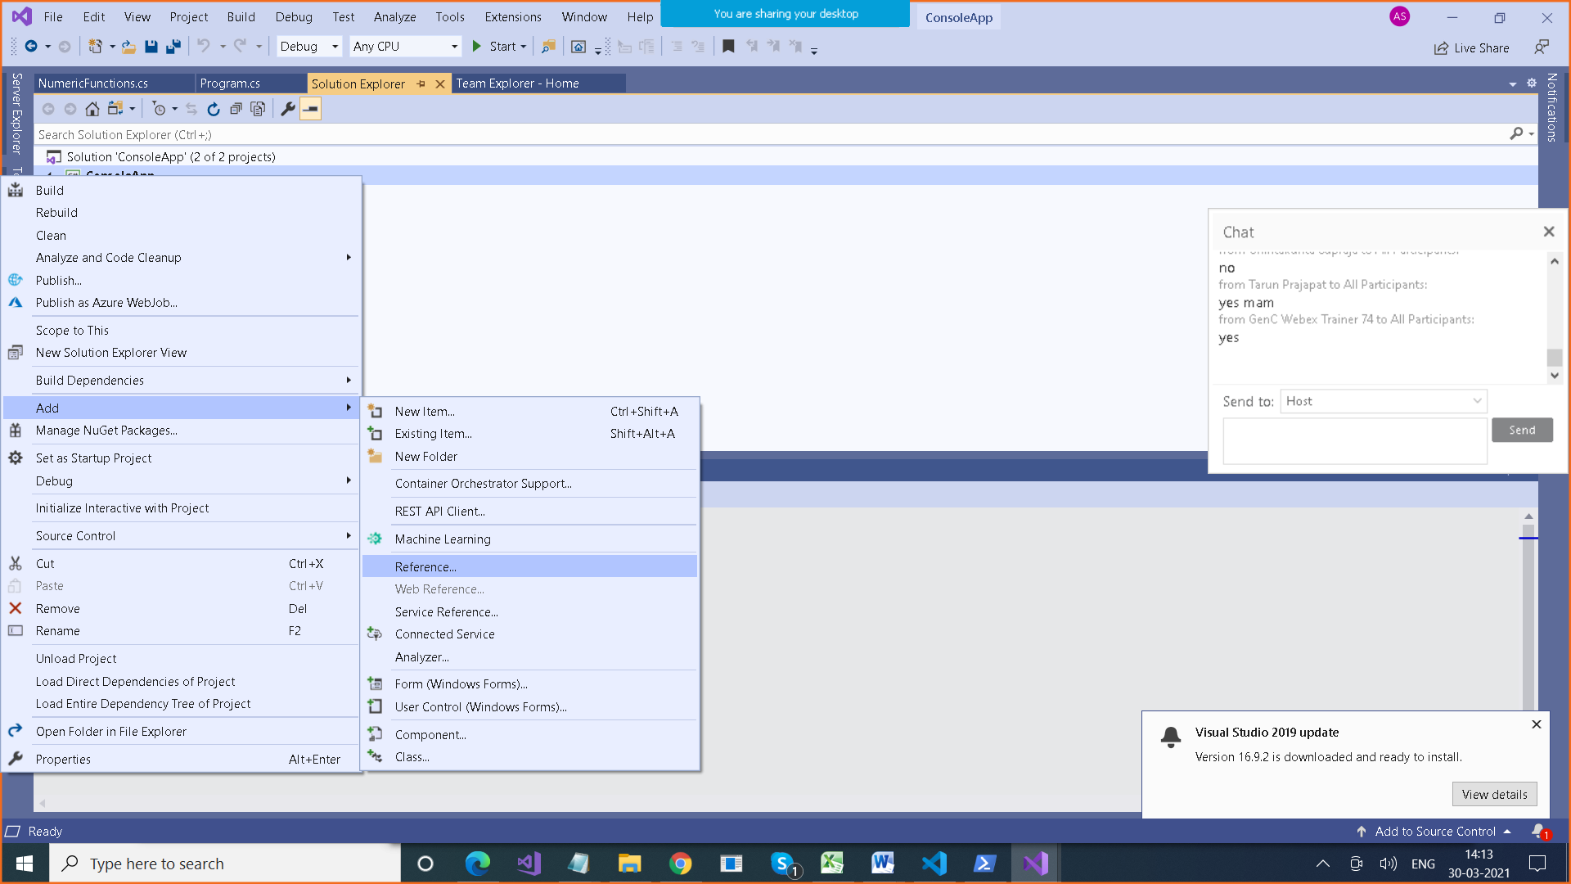

Create WebApi Project

Create a class Student in Models folder

public class Student

{

public int StudentId { get; set; }

public string Name { get; set; }

public String Batch { get; set; }

public int? Marks { get; set; }

public DateTime? DateOfBirth { get; set; }

}

using DemoWebApi.Models;

using System;

using System.Collections.Generic;

using System.Linq;

using System.Net;

using System.Net.Http;

using System.Web.Http;

namespace DemoWebApi.Controllers

{

public class StudentsController : ApiController

{

static List<Student> _studentList = null;

void Initialize()

{

_studentList = new List<Student>()

{

new Student() { StudentId=1, Name="Ajay" , Batch="B001", Marks=89, DateOfBirth=Convert.ToDateTime("12/12/2020")},

new Student() { StudentId=2, Name="Deepak" , Batch="B002", Marks=78, DateOfBirth=Convert.ToDateTime("10/06/2020")},

};

}

public StudentsController()

{

if (_studentList == null)

{

Initialize();

}

}

// GET: api/Students

public IEnumerable<Student> Get()

{

return _studentList;

}

// GET: api/Students/5

public Student Get(int id)

{

Student student = _studentList.Where(x => x.StudentId == id).FirstOrDefault();

return student;

}

// POST: api/Students

public void Post(Student student)

{

if (student != null)

{

_studentList.Add(student);

}

}

// PUT: api/Students/5

public void Put(int id, Student objStudent)

{

Student student = _studentList.Where(x => x.StudentId == id).FirstOrDefault();

if (student != null)

{

foreach (Student temp in _studentList)

{

if (temp.StudentId == id)

{

temp.Name = objStudent.Name;

temp.DateOfBirth = objStudent.DateOfBirth;

temp.Batch = objStudent.Batch;

temp.Marks = objStudent.Marks;

}

}

}

}

// DELETE: api/Students/5

public void Delete(int id)

{

Student student = _studentList.Where(x => x.StudentId == id).FirstOrDefault();

if (student != null)

{

_studentList.Remove(student);

}

}

}

}

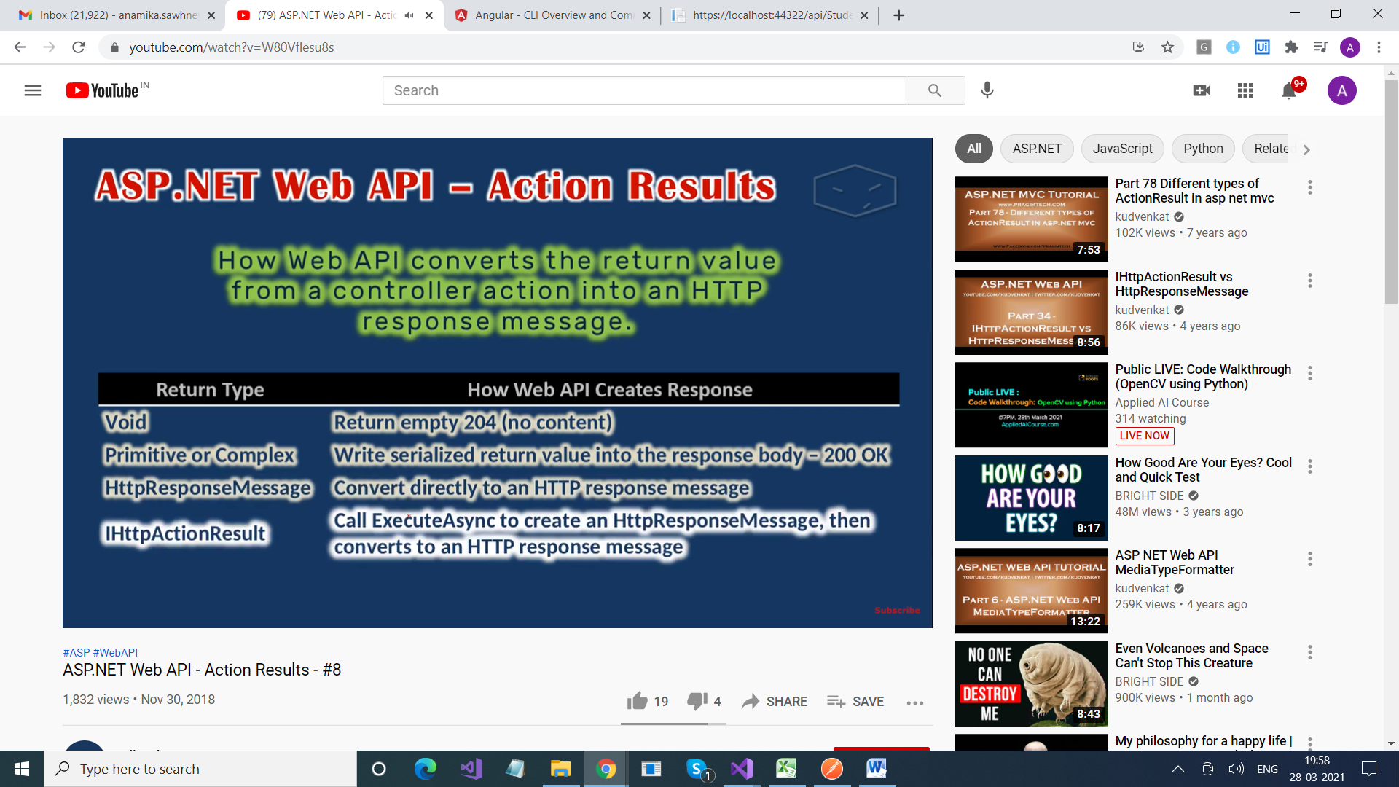

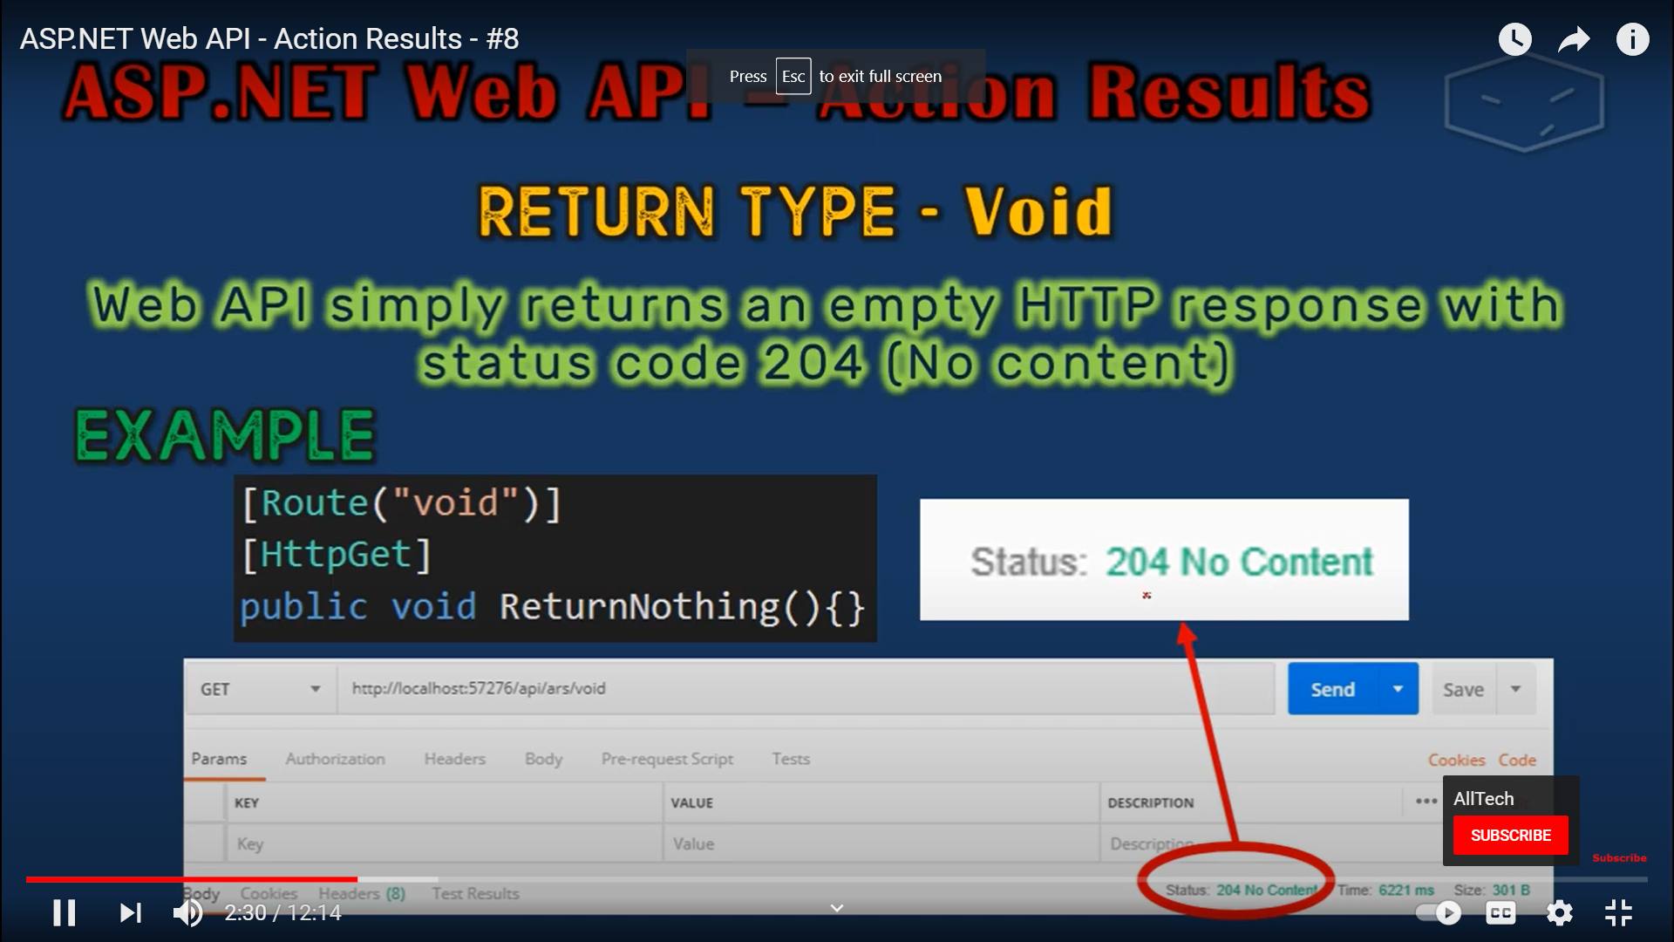

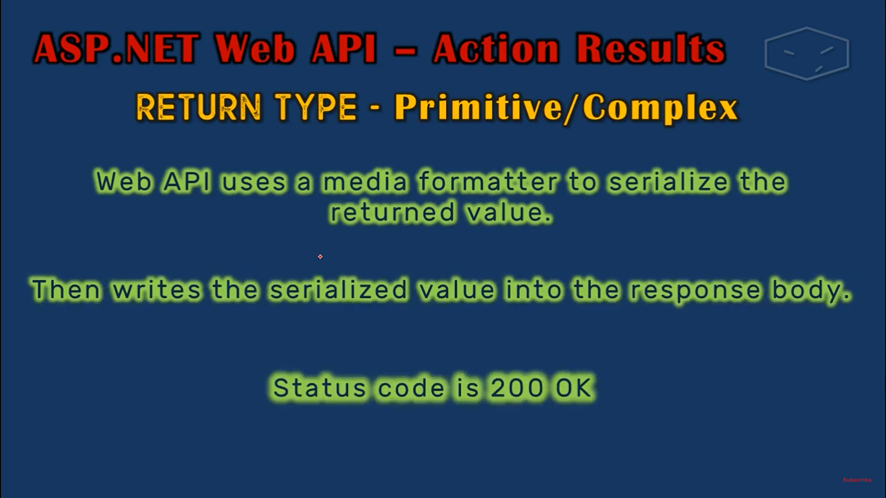

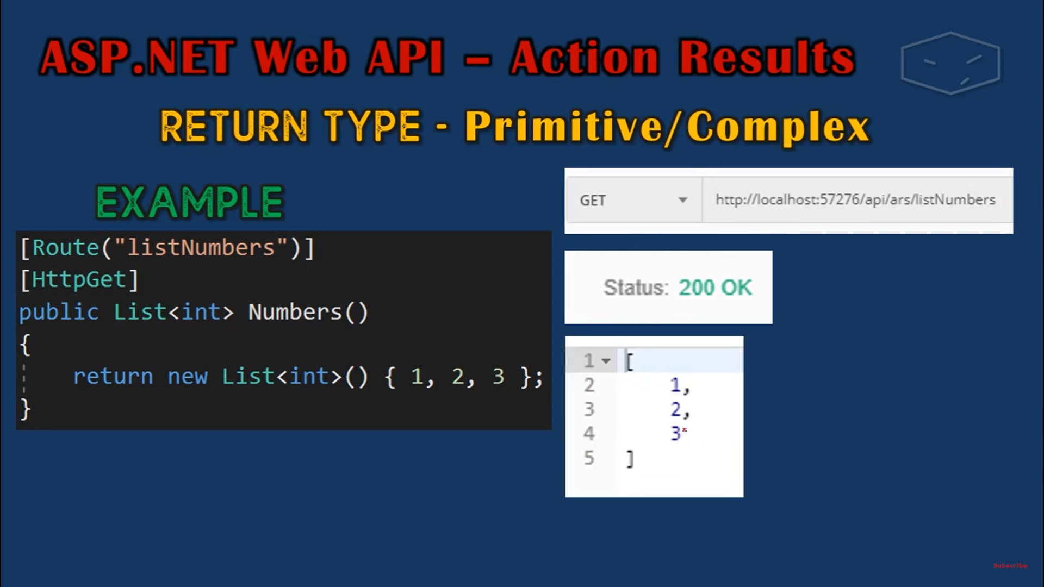

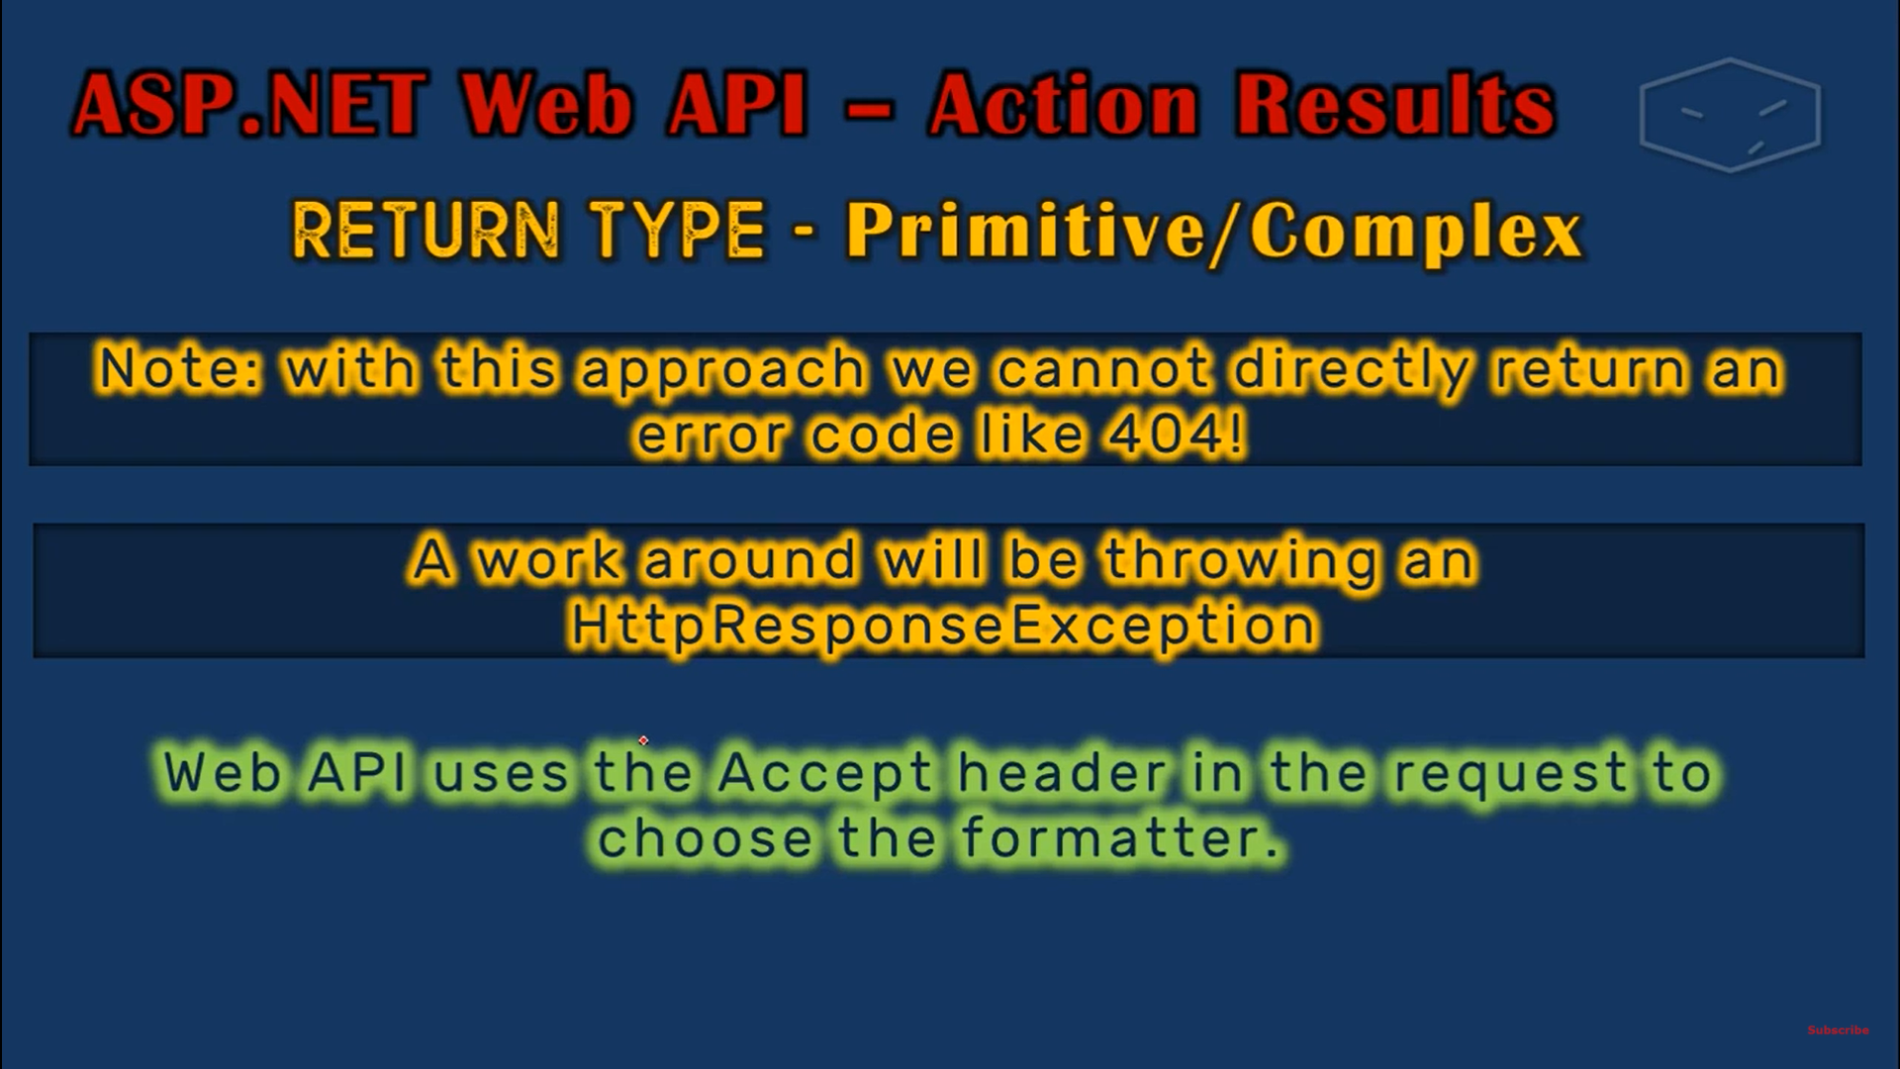

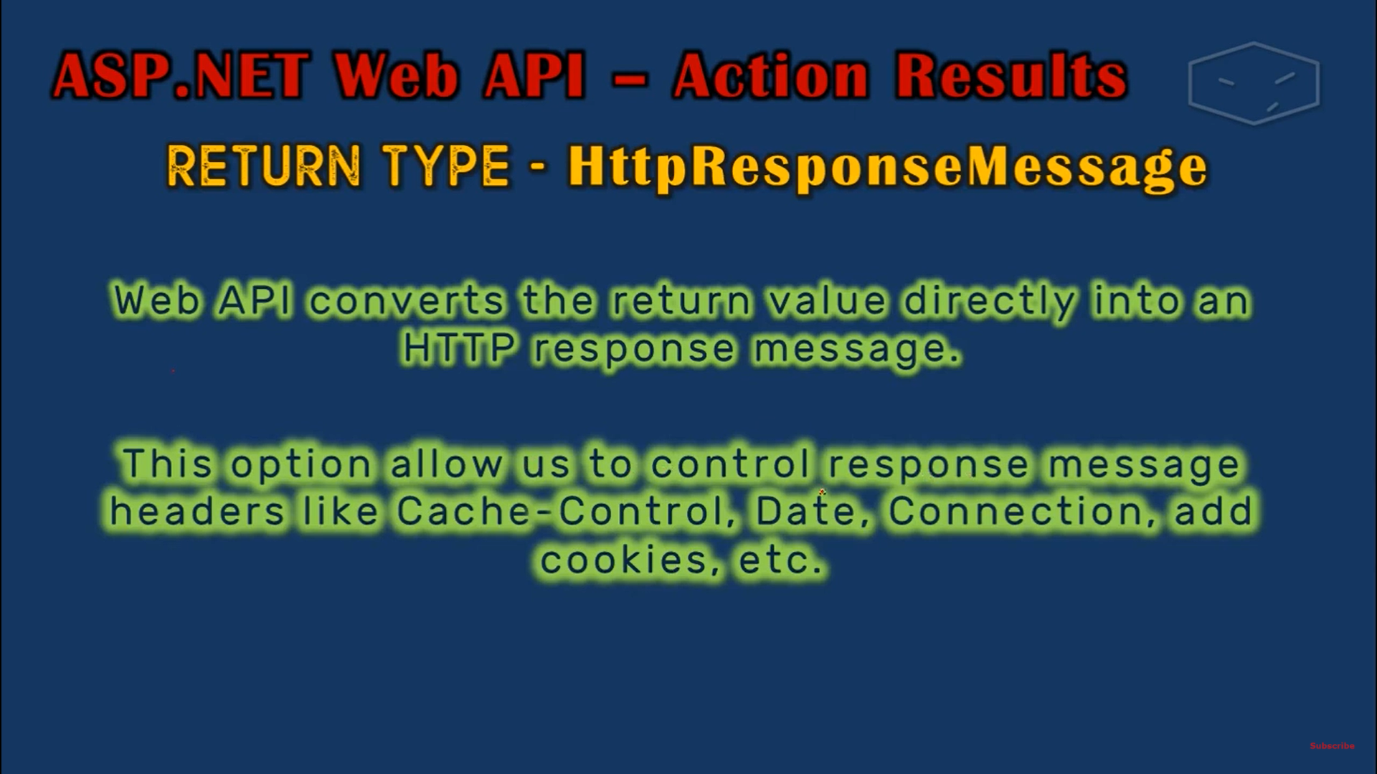

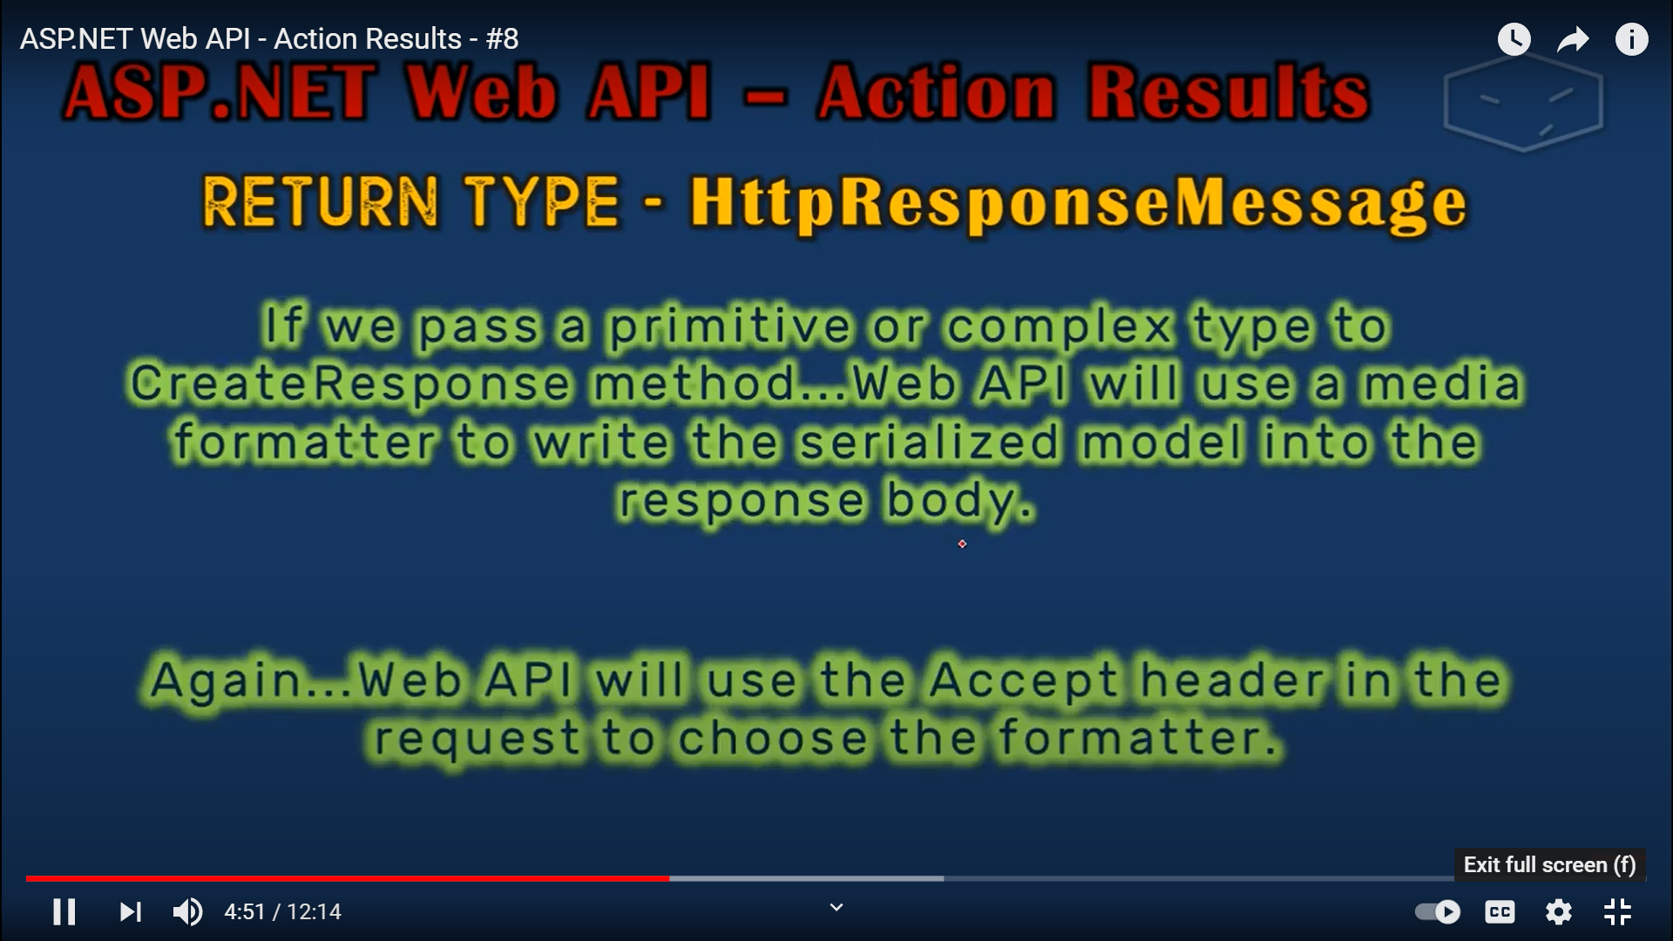

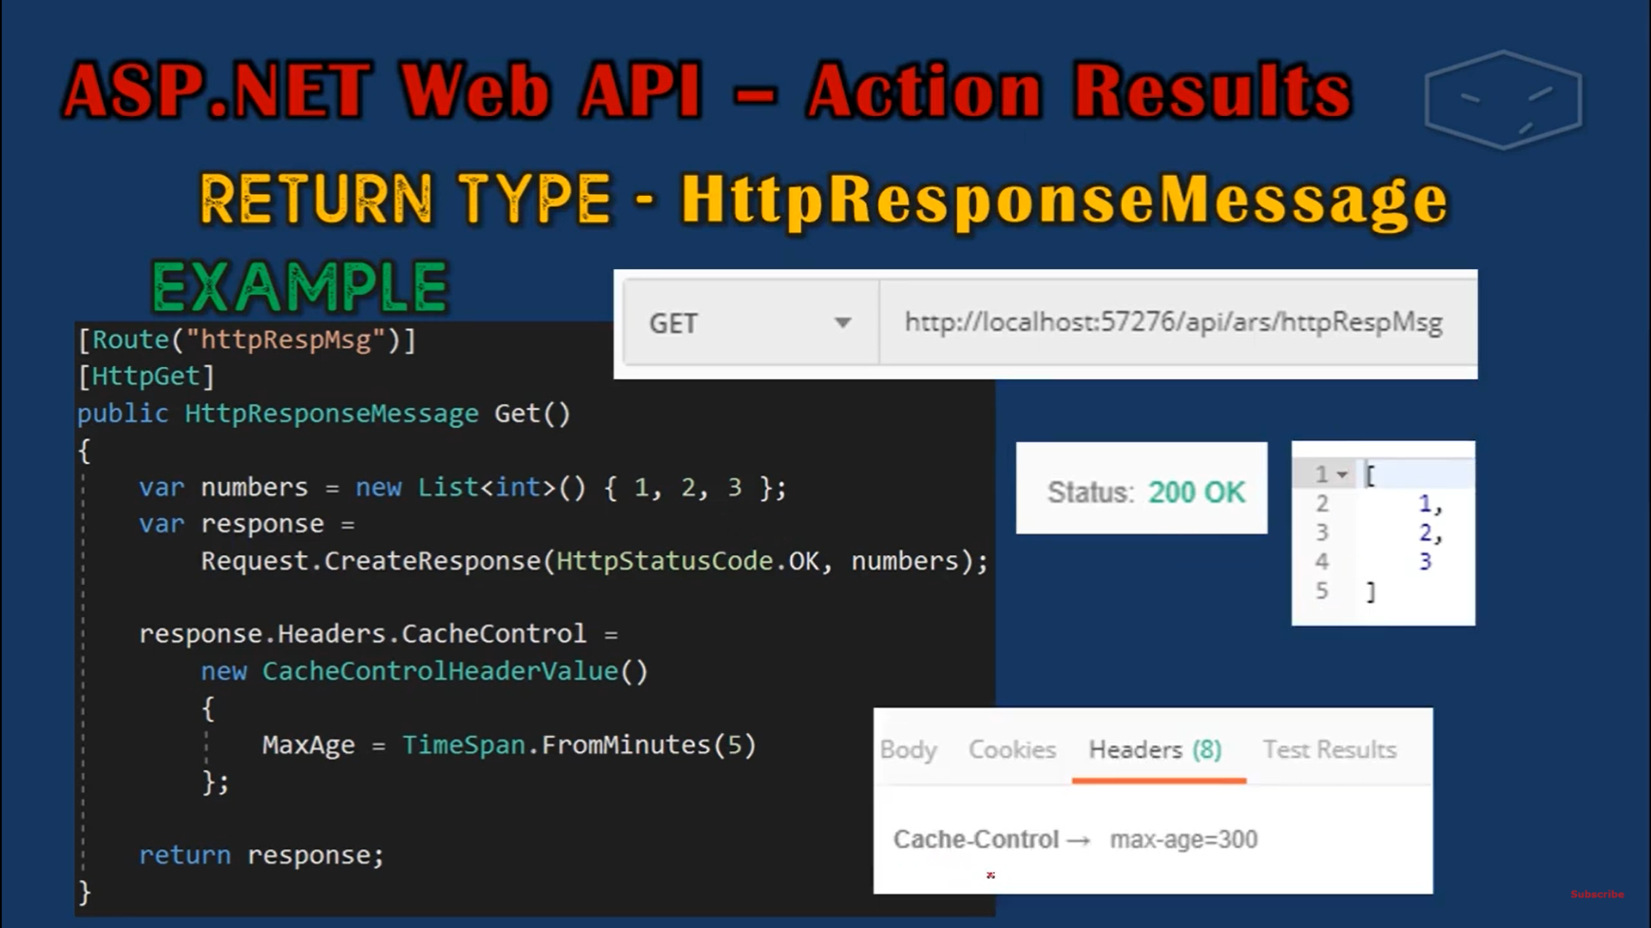

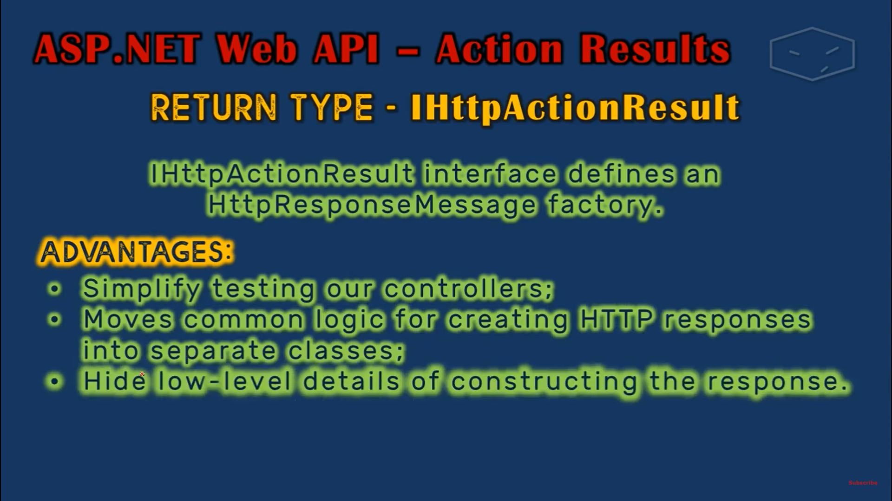

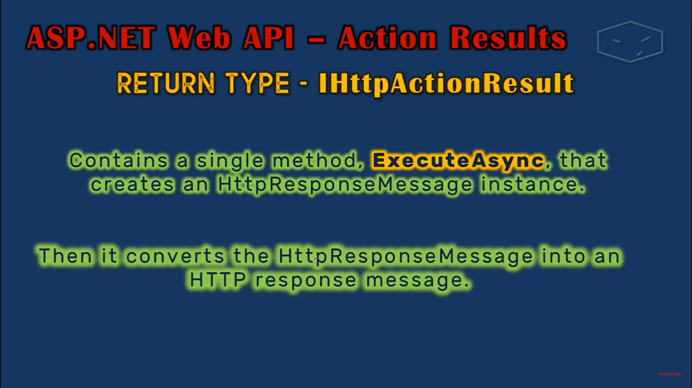

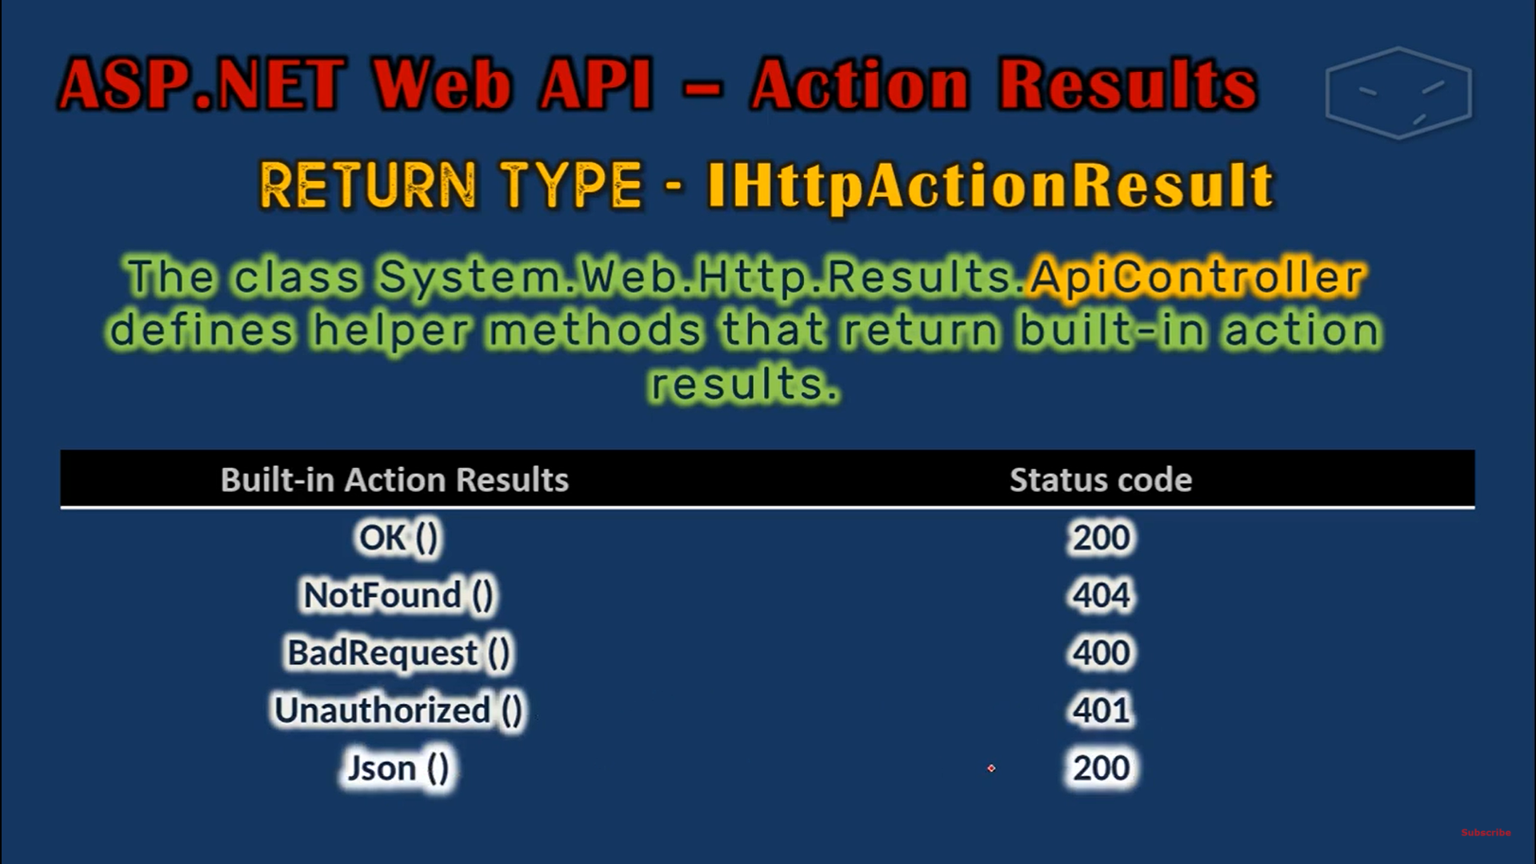

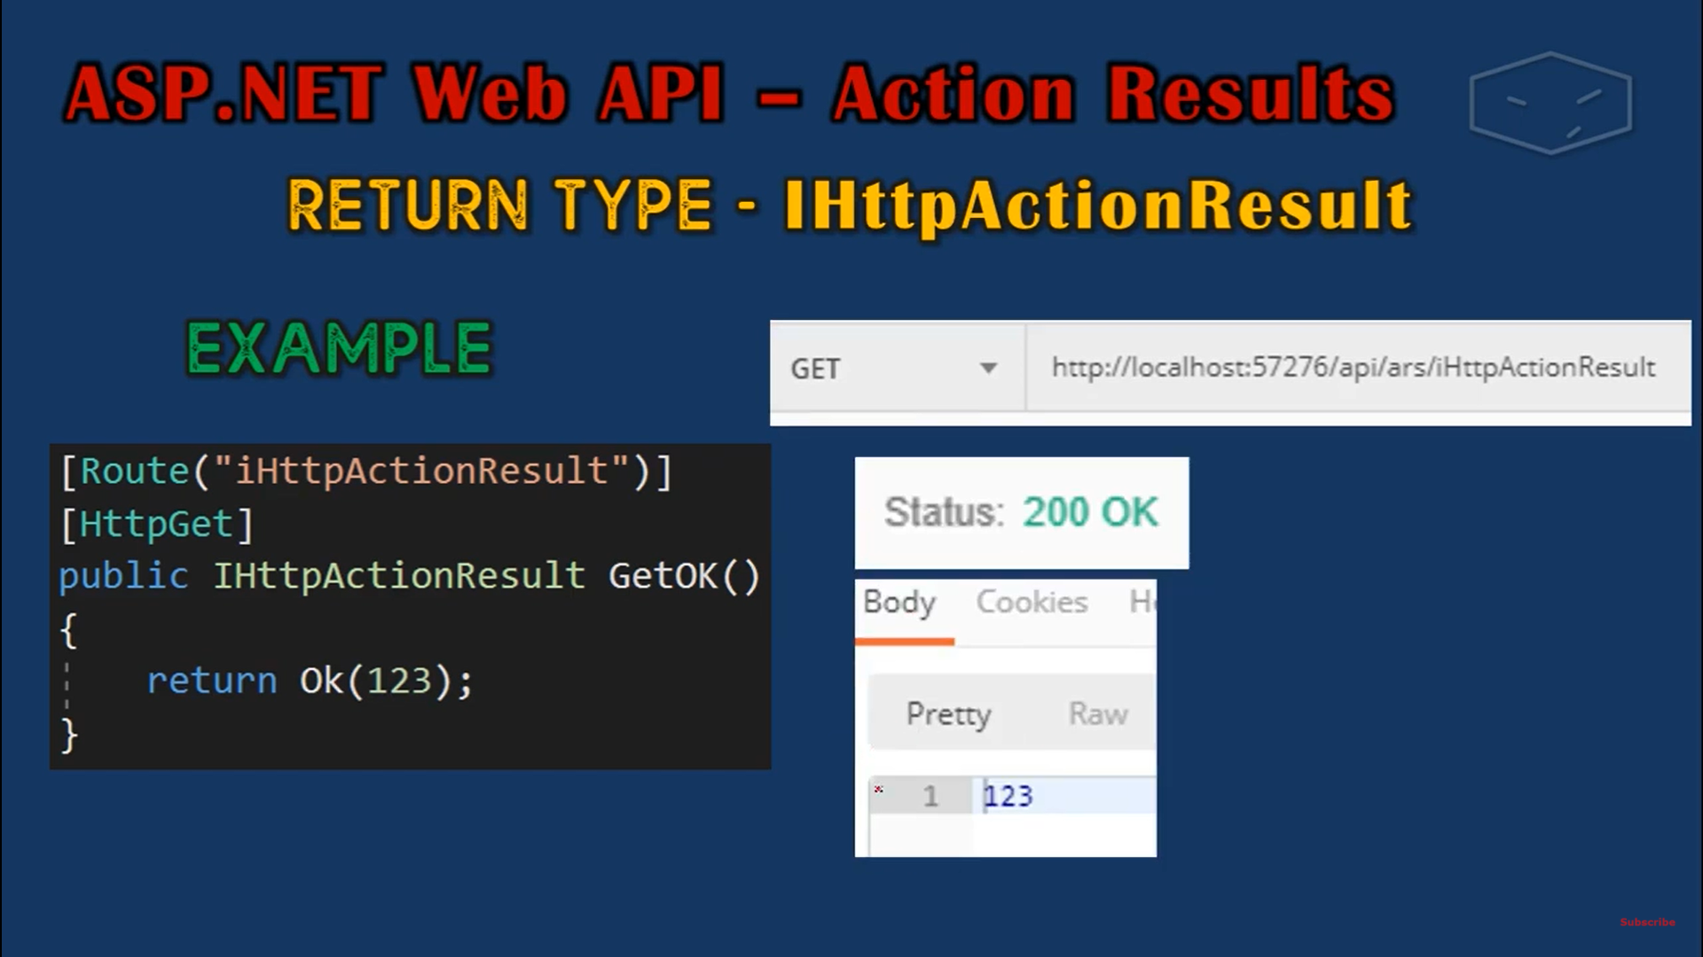

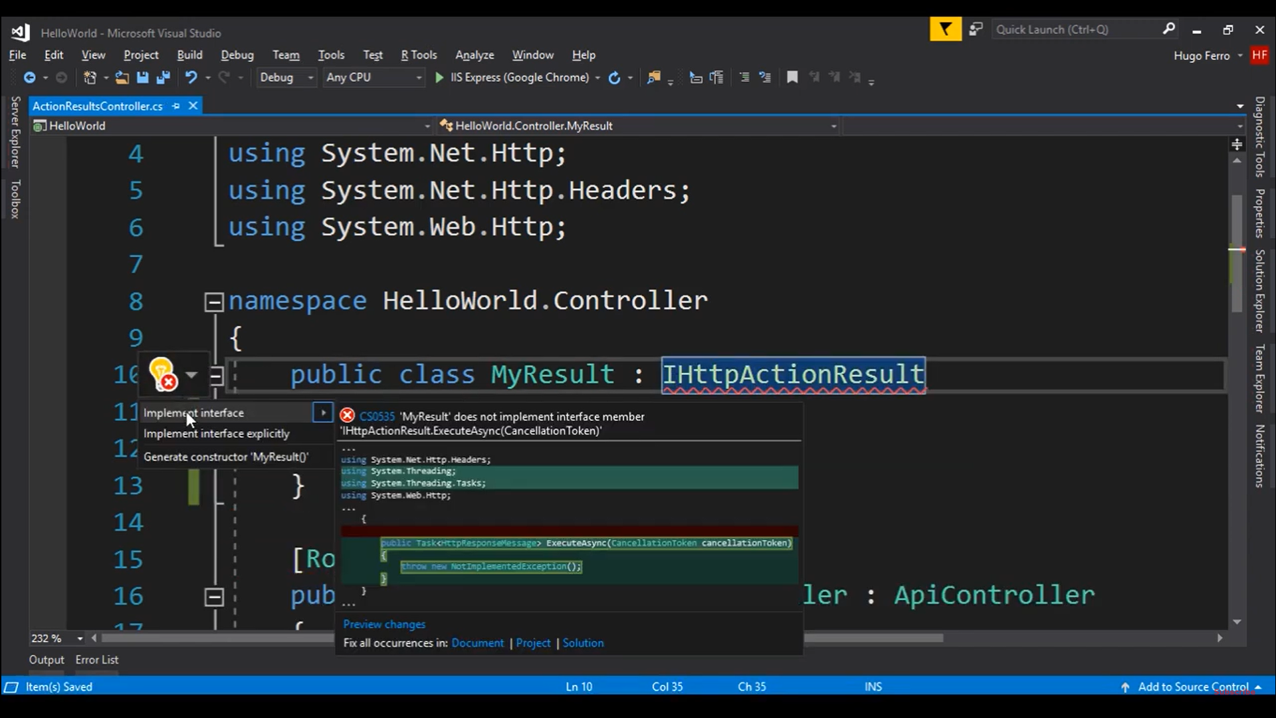

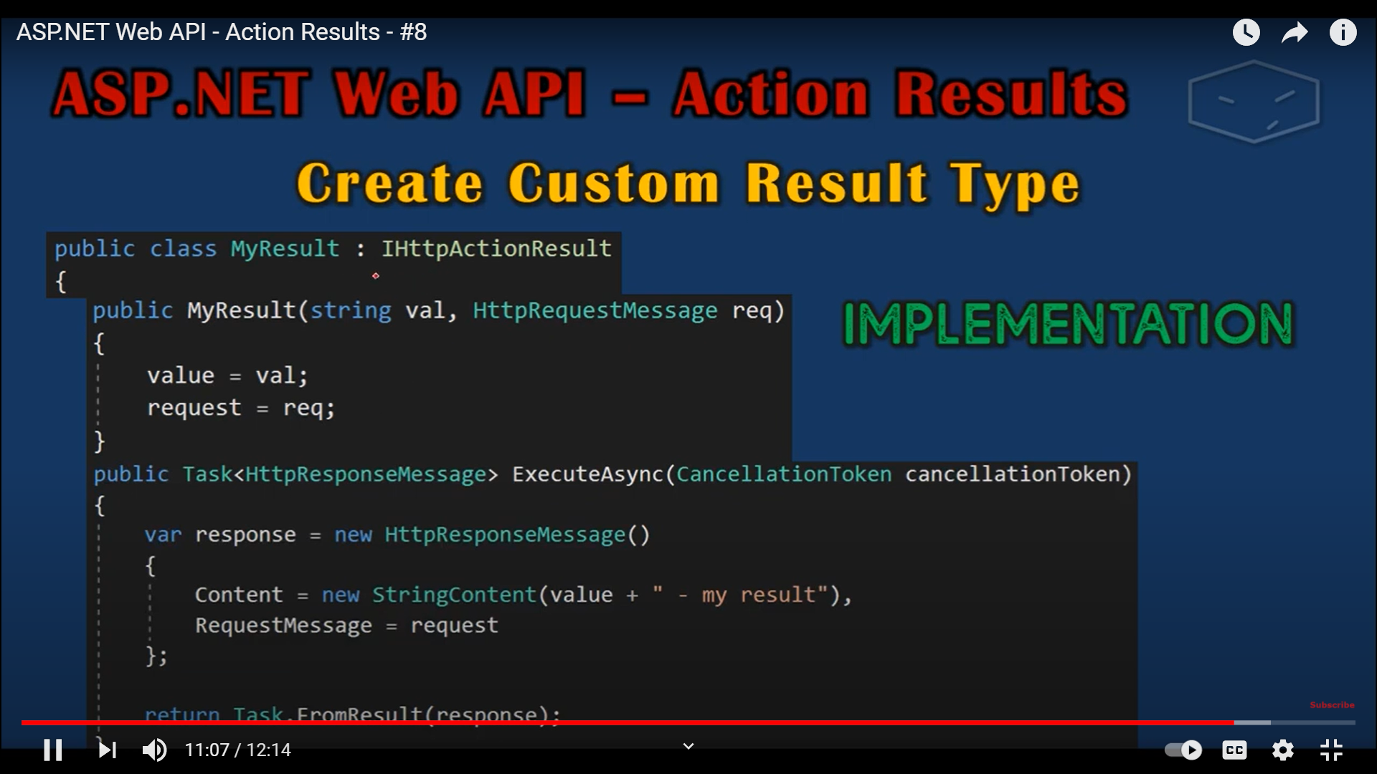

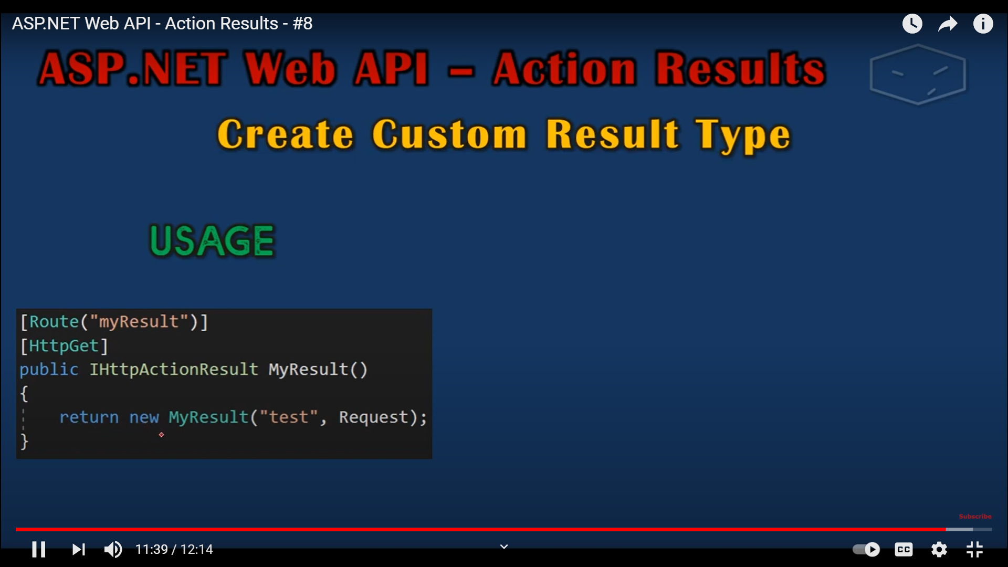

In Web Api1, we have a type called HttpResponseMessage that a controller action method can return. For ex uf we have a method wgich has ti retun list of students

Public HttpResponseMessage Get(

{

Request.CreateResponse(HttpStatusCode.OK, _strudebrList);

}

Public HttpResponseMessage Get(int id)

{if(dtusent—bull)

{

Return Request.CreateERrorResponse(httoStsyaCode.NotFounf,”Student Not found”);

Request.CreateResponse(HttpStatusCode.OK, student);

}

}

// GET: api/Students

public HttpResponseMessage Get()

{

return Request.CreateResponse(HttpStatusCode.OK, _studentList);

}

// GET: api/Students/5

public HttpResponseMessage Get(int id)

{

Student student = _studentList.FirstOrDefault(x => x.StudentId == id);

if (student == null)

return Request.CreateErrorResponse(HttpStatusCode.NotFound, "Student with this ID do not exist");

else

return Request.CreateResponse(HttpStatusCode.OK, student);

}

IN WebApi2 , we have IHTTPActionResult type

We can replace with IHTTPActionResult

Benefits?

2 Ben

1. Code becomes easy to read
2. Unit testing becomes easy

public IHttpActionResult Get()

{

return Ok(_studentList);

}

//// GET: api/Students/5

public IHttpActionResult Get(int id)

{

Student student = _studentList.FirstOrDefault(x => x.StudentId == id);

if (student == null)

return NotFound();

//

return Content( HttpStatusCode.NotFound, "Student not found");

else

return Ok(student);

}

